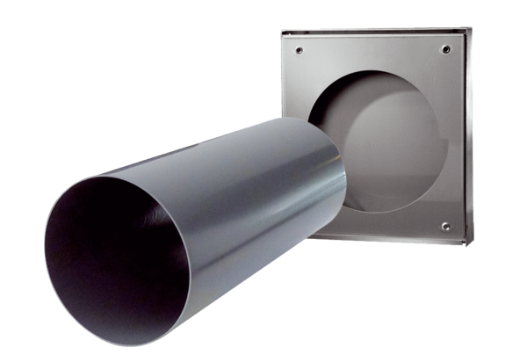Shell kit PP 60 KA-SRPacking unit: 1 pieceRange: K
Article number: 0095.0205Manufacturer: MAICO

