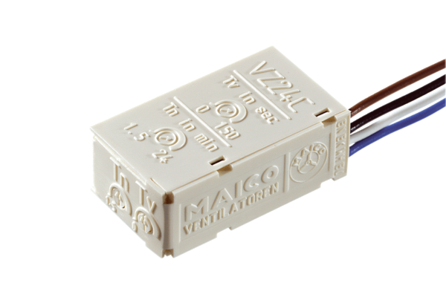Time delay switch VZ 24 CPacking unit: 1 pieceRange: A
Article number: 0157.0822Manufacturer: MAICO

