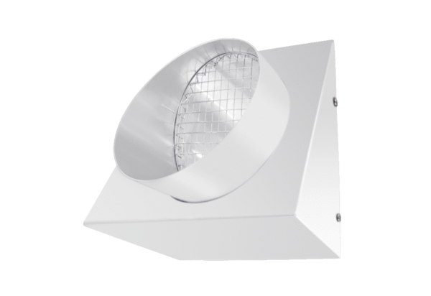Outgoing air wall connection KW-FL 12WPacking unit: 1 pieceRange: K
Article number: 0152.0076Manufacturer: MAICO

