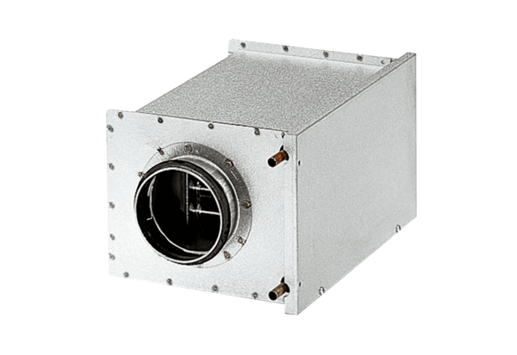Water air heater WRH 12-1Packing unit: 1 pieceRange: C
Article number: 0082.0117Manufacturer: MAICO

