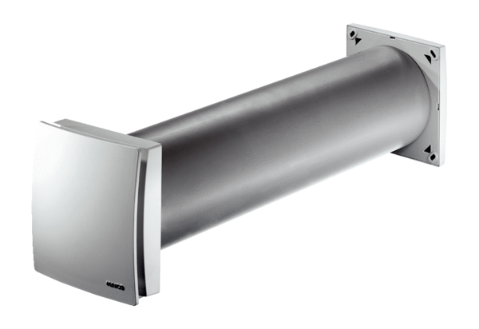Outside air opening ALD 125 VAPacking unit: 1 pieceRange: B
Article number: 0152.0068Manufacturer: MAICO

