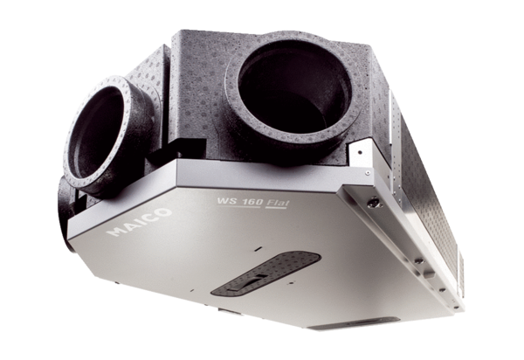Centralised ventilation unit WS 160 Flat BETPacking unit: 1 pieceRange: K
Article number: 0095.0092Manufacturer: MAICO

