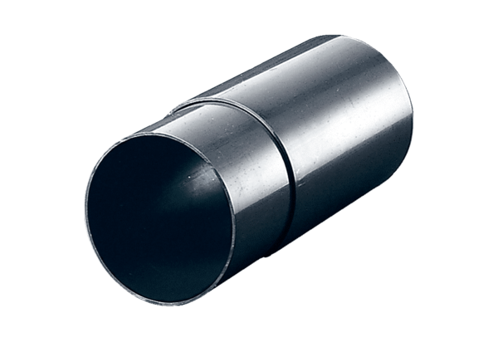Wall sleeve WH 150Packing unit: 1 pieceRange: A
Article number: 0059.1050Manufacturer: MAICO

