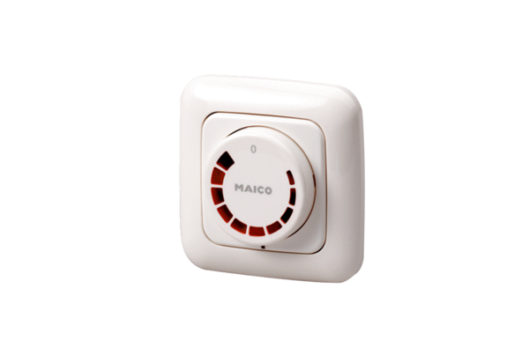Speed controller STU 1Packing unit: 1 pieceRange: C
Article number: 0157.0814Manufacturer: MAICO

