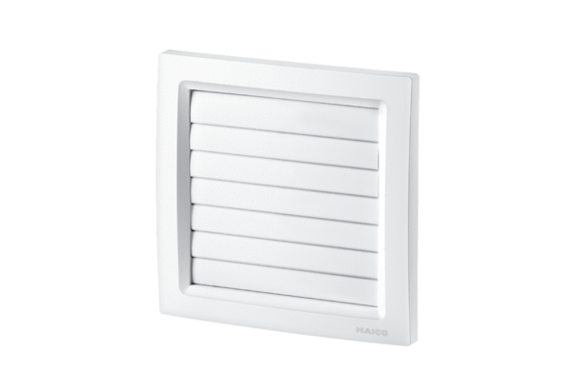Shutter AP 150/1Packing unit: 1 pieceRange: A
Article number: 0059.0996Manufacturer: MAICO

