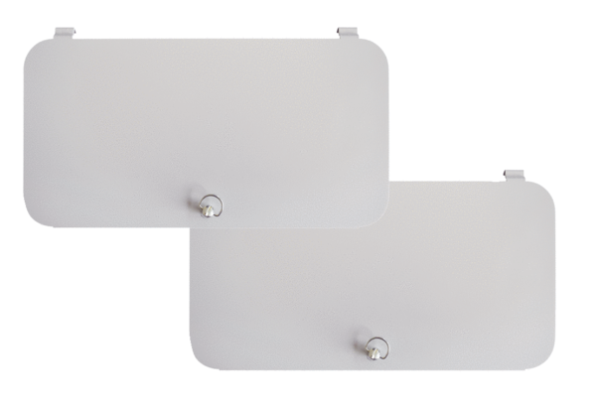Filter locking covers WS-FVA 160Packing unit: 2 piecesRange: K
Article number: 0092.0565Manufacturer: MAICO

