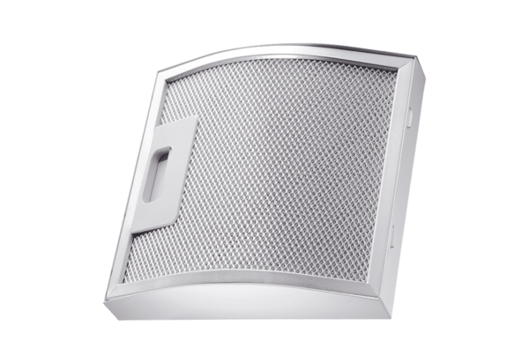Grease filter element for exhaust air FFE 10Packing unit: 1 pieceRange: C
Article number: 0092.0506Manufacturer: MAICO

