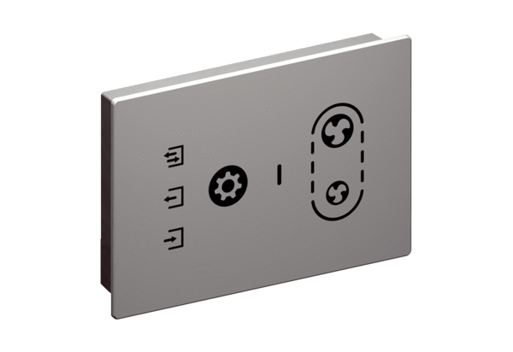Room air control RLS G1 WSPacking unit: 1 pieceRange: K
Article number: 0157.1593Manufacturer: MAICO

