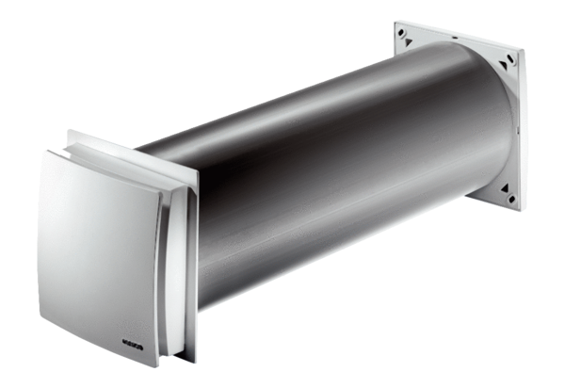Outside air opening ALD 160Packing unit: 1 pieceRange: B
Article number: 0152.0069Manufacturer: MAICO

