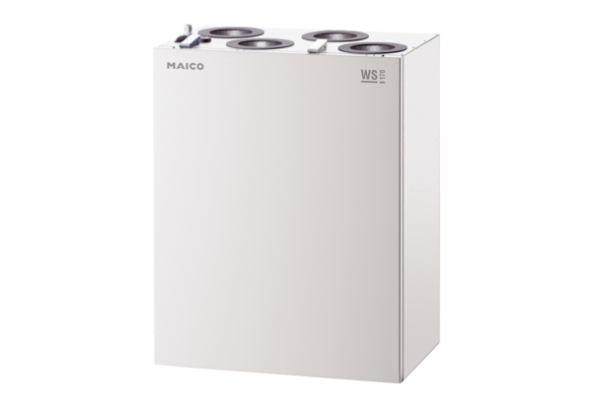Centralised ventilation unit WS 170 KLPacking unit: 1 pieceRange: K
Article number: 0095.0084Manufacturer: MAICO

