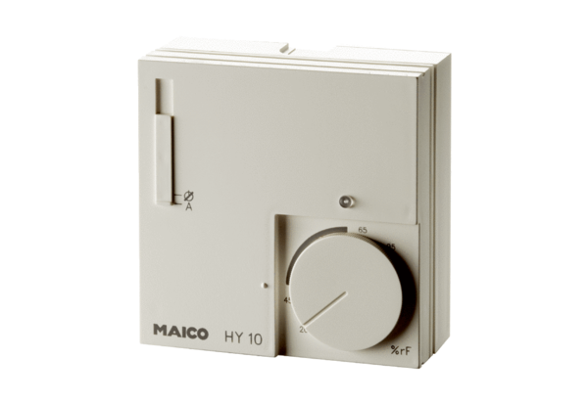Hygrostat HY 10 APPacking unit: 1 pieceRange: C
Article number: 0157.0358Manufacturer: MAICO

