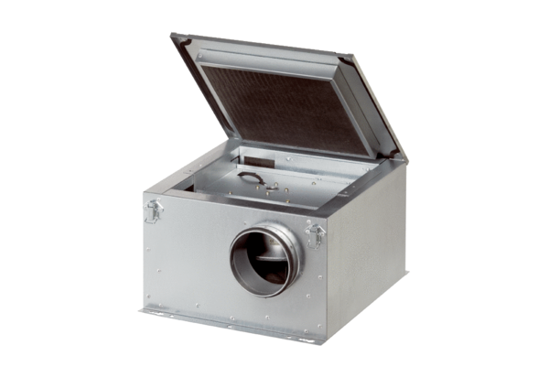Sound-insulated ventilation box ESR 35-2Packing unit: 1 pieceRange: C
Article number: 0080.0615Manufacturer: MAICO

