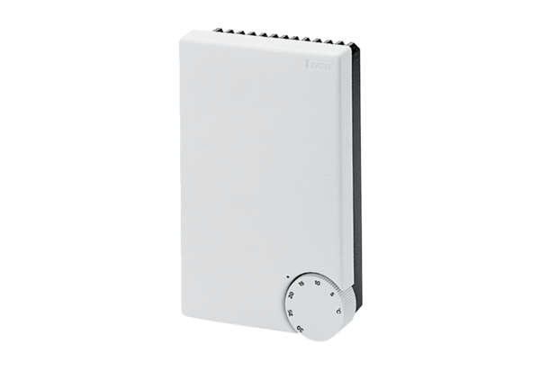Temperature control system DTL 16 PPacking unit: 1 pieceRange: C
Article number: 0157.0825Manufacturer: MAICO

