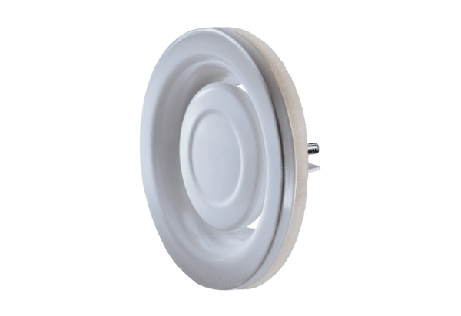Disk valve, metal TFA 10Packing unit: 1 pieceRange: C
Article number: 0151.0369Manufacturer: MAICO

