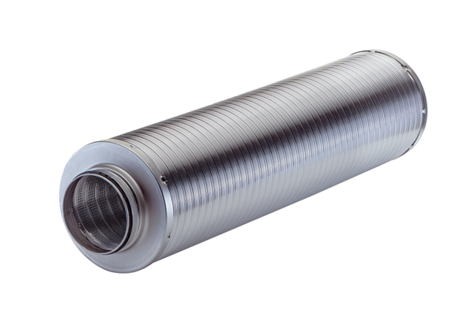Tubular sound absorber RSR 16-1Packing unit: 1 pieceRange: C
Article number: 0092.0595Manufacturer: MAICO

