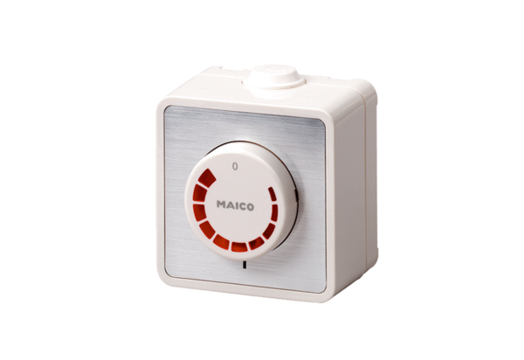Speed controller ST 1Packing unit: 1 pieceRange: C
Article number: 0157.0810Manufacturer: MAICO

