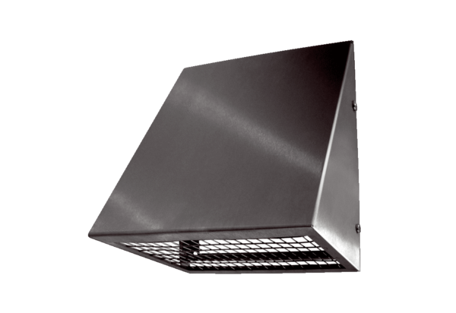Outside air wall connection KW-AL 12EPacking unit: 1 pieceRange: K
Article number: 0152.0073Manufacturer: MAICO

