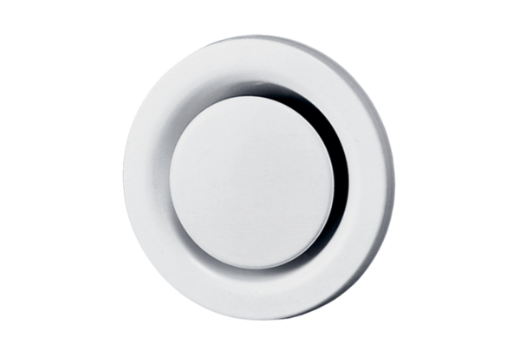Disk valve, metal TM 10Packing unit: 1 pieceRange: C
Article number: 0151.0194Manufacturer: MAICO

