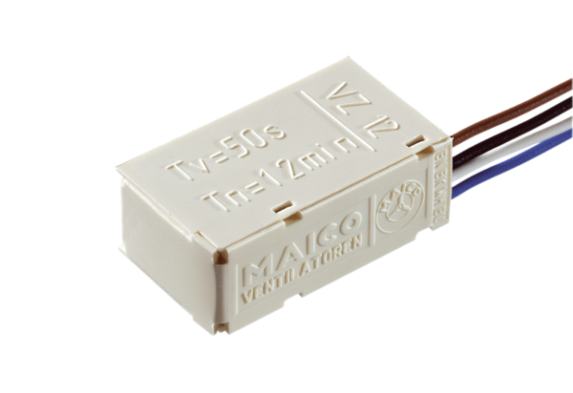Time delay switch VZ 12Packing unit: 1 pieceRange: A
Article number: 0157.0821Manufacturer: MAICO

