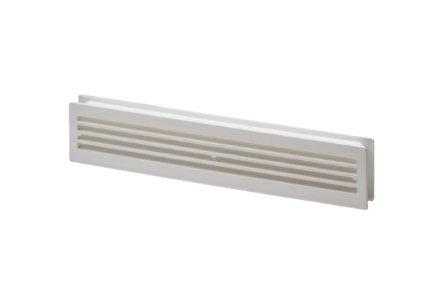Door ventilation grille MLK 45 whitePacking unit: 1 pieceRange: A
Article number: 0151.0126Manufacturer: MAICO

