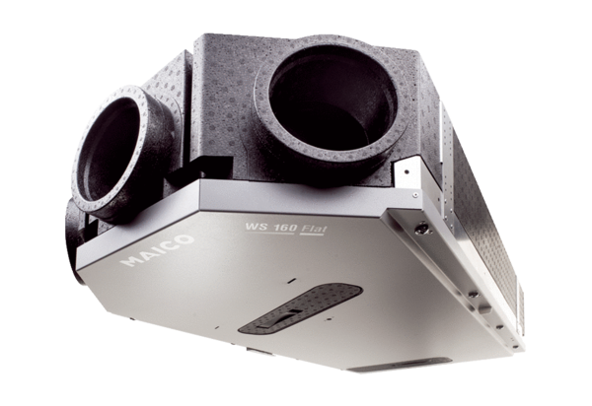Centralised ventilation unit WS 160 Flat KETPacking unit: 1 pieceRange: K
Article number: 0095.0091Manufacturer: MAICO

