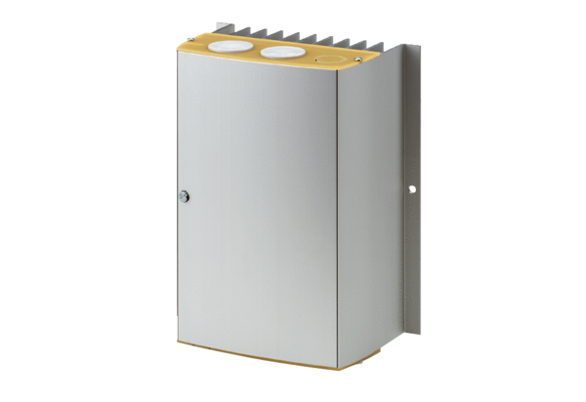Temperature control system DTL 24 PPacking unit: 1 pieceRange: D
Article number: 0157.0586Manufacturer: MAICO

