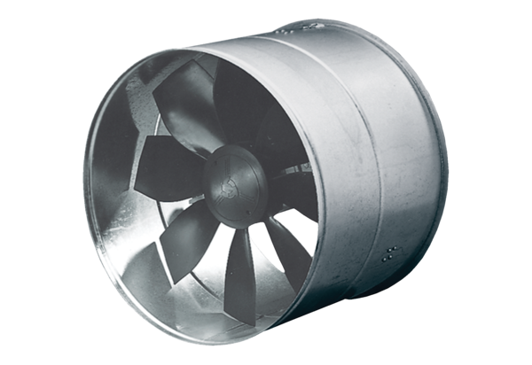AIROTHERM fan DZF 35/64 BHPacking unit: 1 pieceRange: C
Article number: 0085.0033Manufacturer: MAICO

