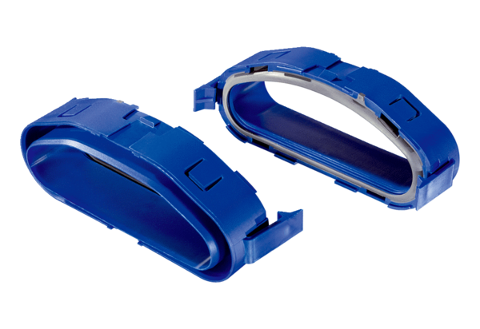Duct fixing adapters FFS-RAPacking unit: 5 piecesRange: K
Article number: 0055.0880Manufacturer: MAICO

