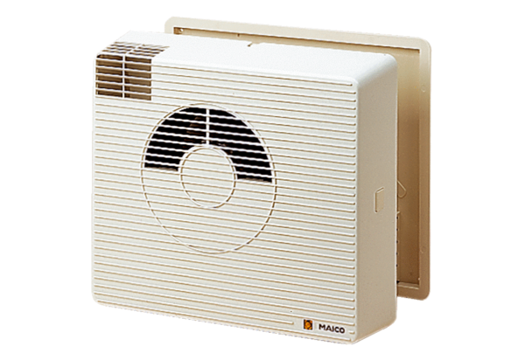Heat recovery unit WRG20-1HPacking unit: 1 pieceRange:
Article number: 0082.0232Manufacturer: MAICO

