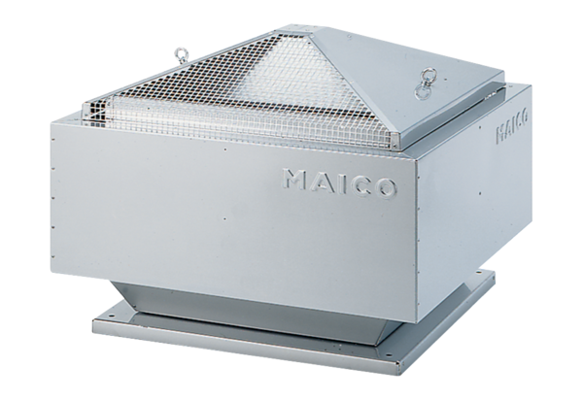Centrifugal roof fan DRD 25/4 BPacking unit: 1 pieceRange: C
Article number: 0087.0102Manufacturer: MAICO

