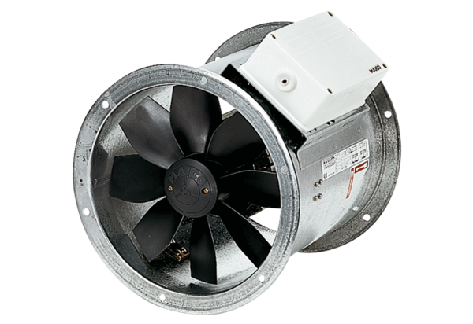Axial duct fan DZR 30/84 BPacking unit: 1 pieceRange: C
Article number: 0086.0042Manufacturer: MAICO

