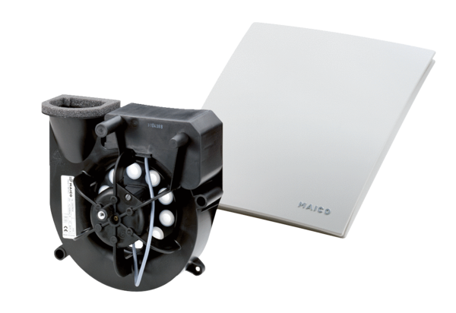Exhaust air element Centro-HPacking unit: 1 pieceRange: B
Article number: 0084.0187Manufacturer: MAICO

