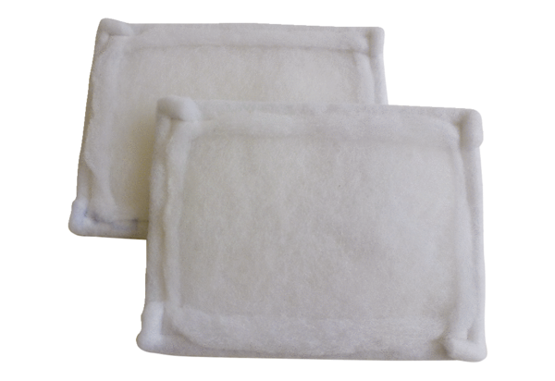Air filter, replacement FE 20-1Packing unit: 2 piecesRange: C
Article number: 0093.1225Manufacturer: MAICO

