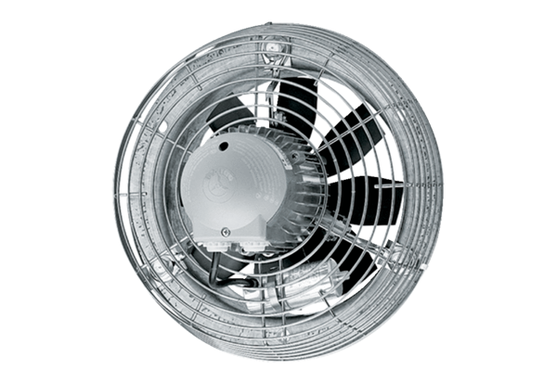Axial wall fan DZS 35/4 BPacking unit: 1 pieceRange: C
Article number: 0094.0018Manufacturer: MAICO

