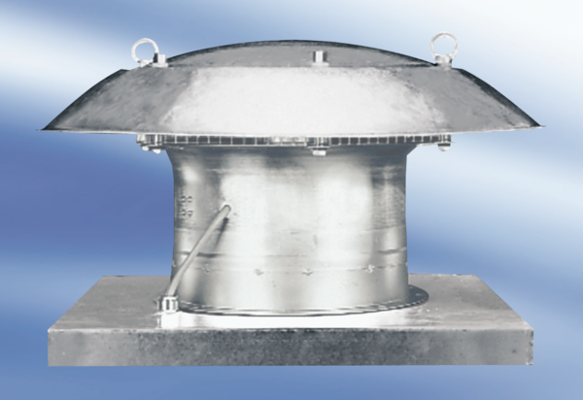Axial roof fan EZD 40/6 APacking unit: 1 pieceRange:
Article number: 0087.0408Manufacturer: MAICO

