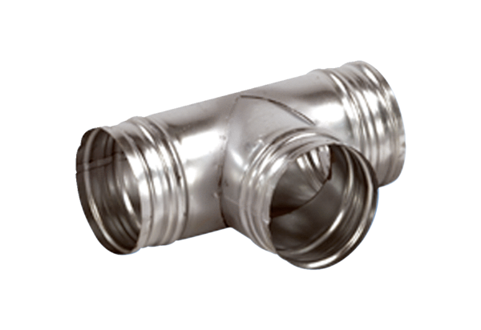90° branch AB 80-100Packing unit: 1 pieceRange: K
Article number: 0055.0346Manufacturer: MAICO

