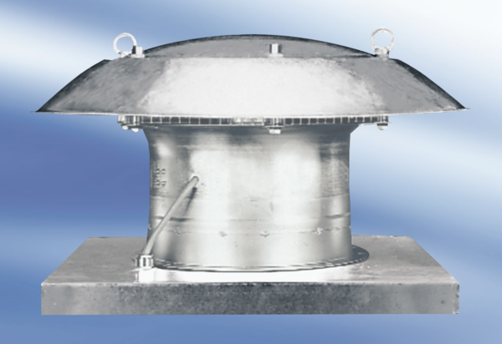Axial roof fan EZD40-4APacking unit: 1 pieceRange:
Article number: 0087.0409Manufacturer: MAICO

