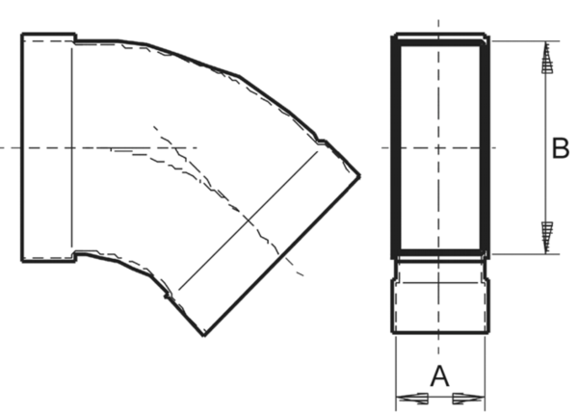45° channel elbows, horizontal KB45H/55/220Packing unit: 1 pieceRange: K
Article number: 0055.0583Manufacturer: MAICO

