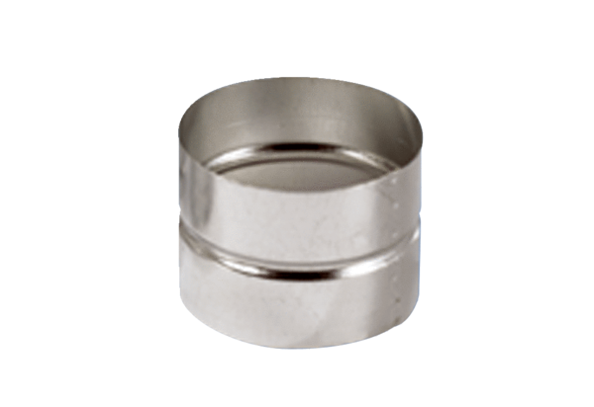Adaptor plug connector SVF 80Packing unit: 1 pieceRange: K
Article number: 0055.0049Manufacturer: MAICO

