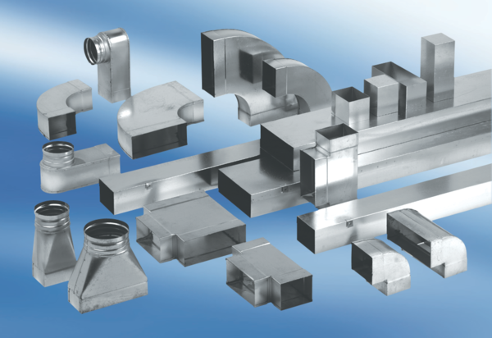Reducer, symmetrical REDS70/170/80Packing unit: 1 pieceRange: K
Article number: 0055.0698Manufacturer: MAICO

