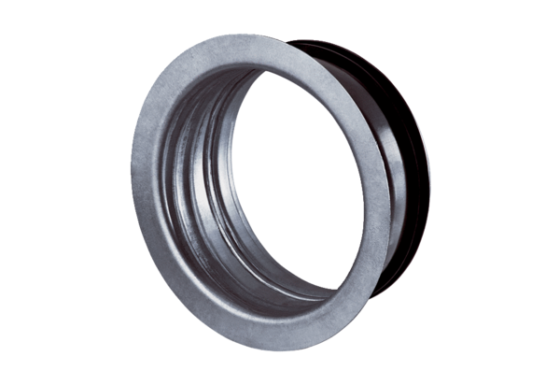Mounting frame for TFA/TFZ EBR-D 20Packing unit: 1 pieceRange: C
Article number: 0092.0497Manufacturer: MAICO

