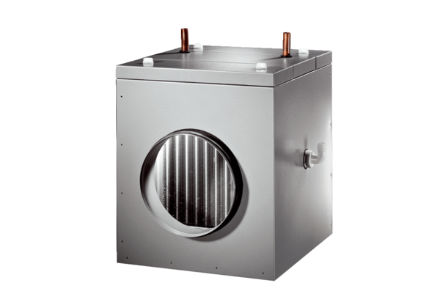Brine-air heat exchanger EW-K 225Packing unit: 1 pieceRange: K
Article number: 0192.0520Manufacturer: MAICO

