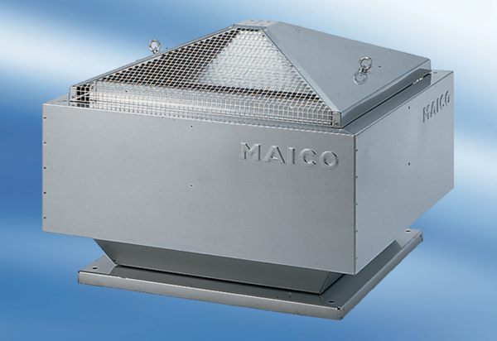Centrifugal roof fan DRD 63/8Packing unit: 1 pieceRange: C
Article number: 0087.0119Manufacturer: MAICO

