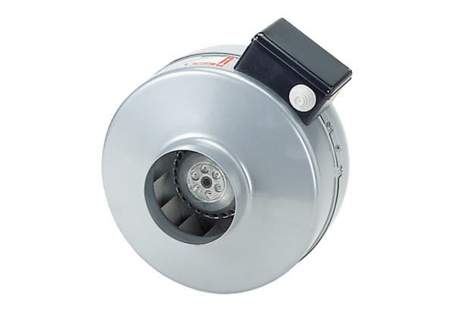Centrifugal duct fan ERR 10/1 ECPacking unit: 1 pieceRange: E
Article number: 0073.0566Manufacturer: MAICO

