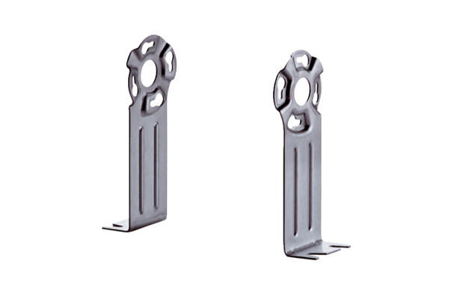Mounting foot FUR 10/12/16Packing unit: 1 pieceRange: C
Article number: 0036.0087Manufacturer: MAICO

