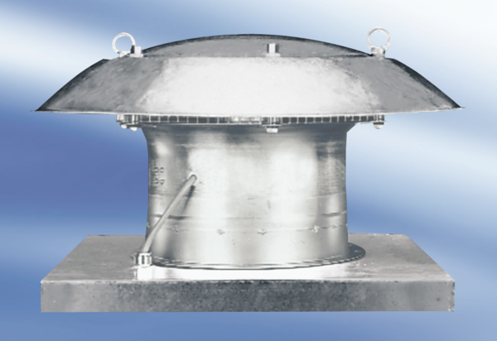Axial roof fan DZD 30/64 APacking unit: 1 pieceRange:
Article number: 0087.0435Manufacturer: MAICO

