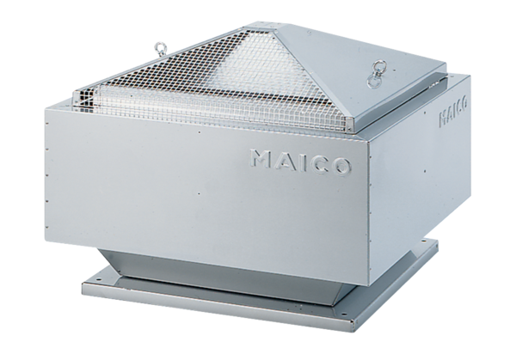Centrifugal roof fan ERD 22/4 BPacking unit: 1 pieceRange: C
Article number: 0087.0001Manufacturer: MAICO

