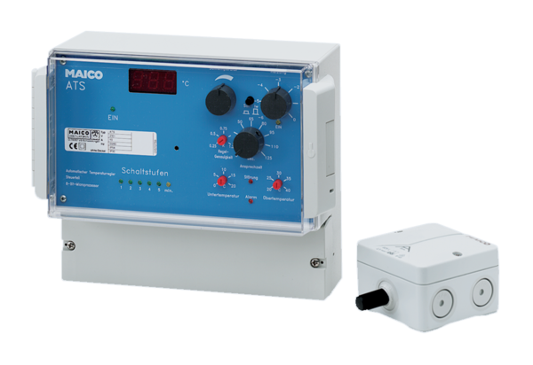Temperature control system ATSPacking unit: 1 pieceRange: C
Article number: 0157.0759Manufacturer: MAICO

