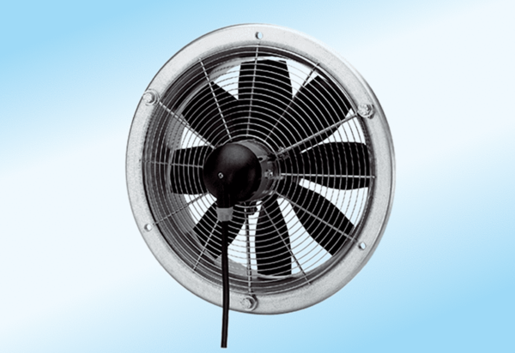Axial wall fan DZS 30/4 A-ExPacking unit: 1 pieceRange: C
Article number: 0094.0106Manufacturer: MAICO

