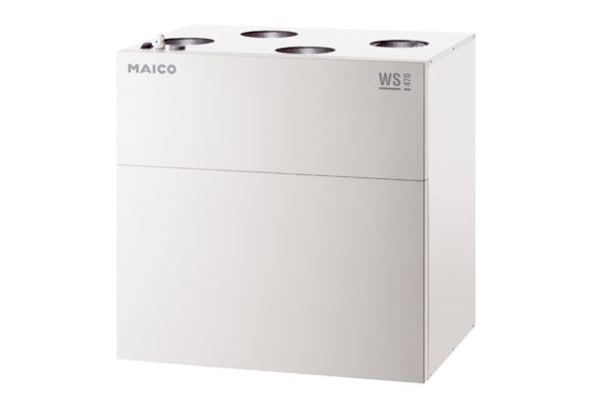Centralised ventilation unit WS 470 KBETPacking unit: 1 pieceRange: K
Article number: 0095.0235Manufacturer: MAICO

